Session 5- Work Education - Monday 2nd March
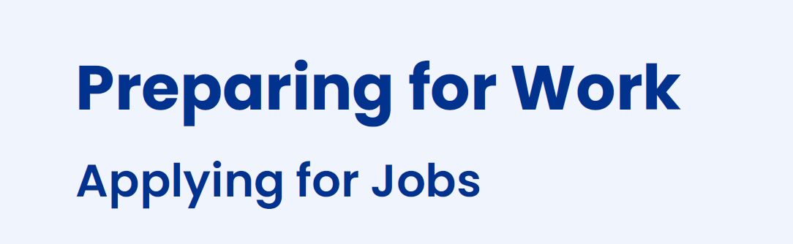
Focus – Students go to KHS career website - login to student area. Select ‘Preparing for Work’ and open the ‘Applying for Jobs’ module.
This is a vital task for students applying for work experience placements OR applying for part-time/casual jobs.
Don’t forget to upload your Career Action Plan and Resume to Learning tasks before continuing with Applying for Jobs or What is Work which we started in our previous class.

